
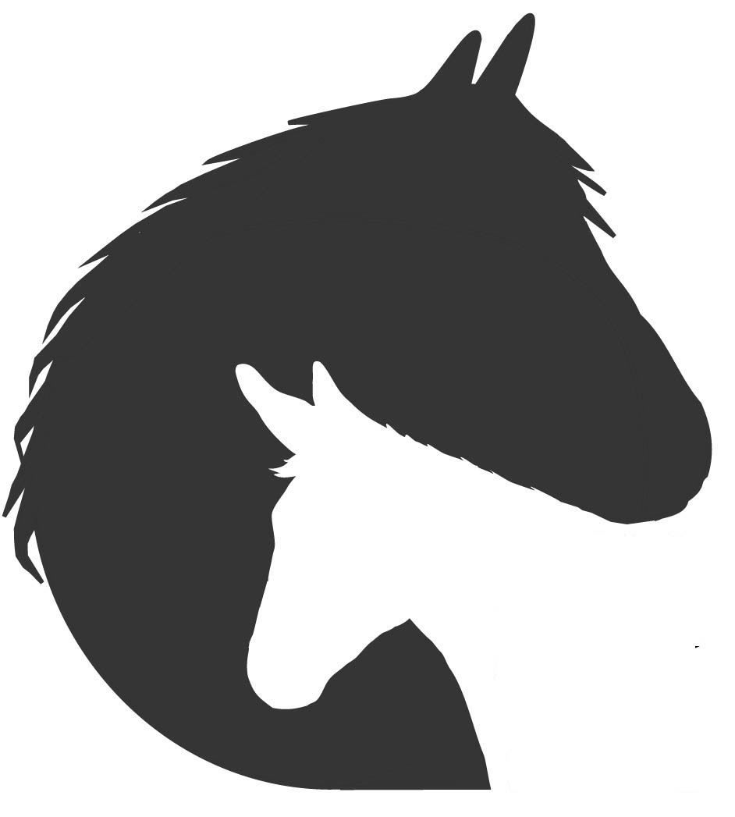
United States Department of the Interior
BUREAU OF LAND MANAGEMENT
Wild Horse and Burro Program

Application for Wild Horse and Burro (WHB) Tissue Collection or Use

(PRIVILEGED COMMUNICATION)
This application template is for research projects proposing to use tissues, DNA or other material from samples that have already been or will be collected during the course of other BLM activities, or from wild horses or burros that may die or be euthanized for reasons unrelated to the project proposed here. If a project involves any live animal handling above and beyond the normal course of BLM activities, or if any funding from BLM is requested, the applicant must use the template for, and send a full “BLM WHB Research Proposal” to the BLM WHB Program. That template is available from the research coordinator (pgriffin@blm.gov).

Under no circumstance may wild horse or wild burro specimens be sold, bartered or traded. Under no circumstances may specimens or DNA from BLM-administered WHB be transferred or used for research purposes without prior approval from the BLM Wild Horse and Burro Program Division Chief.

Guidelines in italics may be deleted prior to submission

A. COVER PAGE.
1a.
 | TITLE OF PROPOSED PROJECT (90 Character Maximum)
1b.
 | NAME OF APPLICANTS / INVESTIGATORS (Principal-Investigator LAST NAME, FIRST NAME; Co-Investigators LAST NAME, FIRST NAME)
2a.
 | NAME OF PRINCIPAL INVESTIGATOR (PI)
2c. |  |  |  |  |  |  |  |  |  | 2d.
 | POSITION TITLE |  |  |  |  |  |  |  |  |  |  |  |  | EMAIL
2e. |  |  |  |  |  |  |  |  |  | 2f,g.
 | INSTITUTION AND DEPARTMENT |  |  |  |  |  |  |  |  |  |  |  |  | PHONE FAX
2h. | ADDRESS: ____________________________________________________________________________________________________________________
3a. |  | THIS IS A: (Mark one only) |  | ___ NEW APPLICATION |  |  |  |  |  |  |  |  |  |  | ___ CONTINUATION
3b. |  | DATES OF PROPOSED PROJECT :
 |  |  |  |  |  | START |  |  |  |  |  |  |  |  |  |  | END
 | AGREEMENT: It is understood and agreed by the undersigned if this proposal / application is approved it will be according to the terms of the application and the stipulations set forth in any accompanying instructions from BLM made at the time of proposal approval. In addition, a written agreement appropriate for the nature of the proposed work (e.g., Memorandum of Understanding, Assistance Agreement, Task Order, or letter of agreement) may be required to outline the obligations of the applicant / investigator and the BLM in the conduct of the study.
 | PRINCIPAL INVESTIGATOR ASSURANCE: I agree to accept responsibility for the conduct, completion and reporting of the project proposed here and to provide the agreed upon progress and final reports.
4a. | SIGNATURE OF PRINCIPAL INVESTIGATOR: |  |  |  |  |  |  |  |  |  |  |  |  |  |  |  |  |  |  |  | DATE:
 | CERTIFICATION AND ACCEPTANCE: I certify that the statements made in this application are true and complete to the best of our knowledge, and I accept the obligation to comply with the above agreement. I understand that the Applicant / Investigator and his/her institution will be responsible for any expenses incurred by this project, except for those that are specifically identified by BLM as being the responsibility of BLM.
4b. | OFFICIAL SIGNING FOR ORGANIZATION (For individuals , this may be the Applicant / Investigator): |  |  |  |  |  |  |  |  |  |  |  |  |  |  |  |  |  |  |  | DATE:
4c. | ADDRESS: |  |  |  |  |  |  |  |  |  | 4d.
 |  |  |  |  |  |  |  |  |  |  |  |  |  | EMAIL
 |  |  |  |  |  |  |  |  |  |  | 4e,f.
 |  |  |  |  |  |  |  |  |  |  |  |  |  | PHONE

BLM Wild Horse and Burro Program
Application for Wild Horse and Burro (WHB) Tissue Collection or Use

Privileged Communication

All pages must be type written in font 12, single-spaced with one-inch margins, with pages numbered at bottom. Guidelines in italics may be deleted prior to submission.

B. ABSTRACT OF PROPOSED PROJECT AND LIST OF ALL STUDY PERSONNNEL

Abstract of proposed project (350 word maximum):

Name, official title, department, project responsibilities of all professional personnel to be engaged in project:

C. PROJECT PROPOSAL
Do not exceed section page limits without prior approval.

1. Goals / Objectives / Hypotheses: (not to exceed 2 pages)
Sections 1 is a critical part of your proposal. This section should describe the rationale behind the proposed work, establishing the need for the knowledge that will be gained, explaining to reviewers the concept and the competency of the proponents seeking approval. The Goals should clearly identify the problem or need being addressed by the research and the known science as well as the knowledge gap that will be filled by the completed work. The Goals should be stated from a long-term overarching point of view. The Objectives should be introduced by naming or describing the type of study design that will be used, the type and character of the animals involved and the location of the study followed by describing specific achievements that will be made including mention of the scientific methodology that will be used. The Hypotheses can be introduced in general terms but should also establish that the proposal includes specific testable hypotheses that support each stated objective. The Hypotheses should be numbered, and there should be a brief description of how each hypotheses will be tested.

2. Specific Tissues or Samples Requested, and Required Handling: (not to exceed 3 pages)
List the specific samples or tissues that you are requesting. Be sure to specify the number of samples of each tissue type requested, and the preferred source of those samples. Indicate clearly what specimen handling procedures must be followed, who will be expected to do each step of this work (your organization, or BLM staff) and, if BLM staff time for specimen collection or preparation is requested, whether BLM staff will require any special training. If the tissues you are requesting must be taken from live animals, you must submit a research proposal to the BLM, not this application.

3. Background and Significance: (not to exceed 2 pages)
Briefly discuss the background of the proposal; critically evaluate existing knowledge and identify gaps that would be addressed by the proposed research. State concisely the importance of the proposed research by relating the objectives of the study to the broad, long-term goals of the BLM Wild Horse and Burro Program. Describe the impact, if any, of the potential outcome of the investigation to WHB management, health, and well-being. If applicable, indicate how this effort will advance the fields of equine science, veterinary medicine, or surgery. Provide any relevant preliminary data (national, regional, local, institutional/ practice) that may support the proposed investigation. The rationale for the proposed work must be established by the information presented here. Applicants may also describe preliminary studies that are pertinent to the application, and may provide other information that will help establish the competence of the investigator to undertake the proposed study. WHB should not be regarded as a convenient or inexpensive source of equine tissues. This section must explain and establish why samples from WHB in particular offer a unique opportunity for research in this situation. If specimens are to be used in a research museum setting, indicate the scientific and educational value that the specimens will have in that context, refer to the museum’s mission, and indicate what curatorial practices are in effect to safeguard the value of the specimens. Indicate here what your specific plans are for publication and dissemination of your results, in addition to the required annual and final reporting to BLM outlined under #6, below.

4. Research/Teaching Approach: (not to exceed 3 pages)
The project design and procedures should be described in detail. Include the process by which samples and data will be collected. Discuss potential difficulties and limitations of the proposed procedures. Provide a tentative sequence or timetable for the investigation (e.g., a Gantt chart).

5. Statistical Methods: (not to exceed 1 page)
Describe what type of data will be collected and how the data will be analyzed and interpreted. Describe the assumptions that will be made during the analysis and how particular outcomes would be interpreted. State the statistical methods to be used. Specify the number of observations required to yield statistically significant results at a particular confidence level (e.g., 95%) or with a defined level of sufficient statistical power.

6. Reporting:
Your signature below affirms your agreement to provide a final report, following the template provided below, to be received by the BLM WHB research coordinator no later than 3 months after completion of the project. If your project will take more than one year to complete, BLM requires a progress report once per year, following the format provided at the end of this template. The first progress report shall be received by the BLM WHB research coordinator no later than one year after receipt of samples. BLM will require the return of specimens unless timely reporting is completed. For museum collections, a copy of accession documents and signature of assurance that the specimens are secure will serve as the final report. Different reporting requirements may be established if a BLM assistance agreement is established for this project, in which case the reporting requirements of that agreement would take precedence over those outlined here.

Signature of Principal Investigator: __________________________________ Date: ___________________

7. References: (No limit)
Provide complete literature citations for all references cited in the proposal.

8. Appendices: (No limit)
Other supporting information may be included as appendices. These may include preliminary data, proposed standard operating procedures (SOPs), or other relevant materials.

D. BIOGRAPHICAL SKETCH
Privileged Communication

(Complete a biographical sketch for Principal Investigator, each Co-Investigator, Graduate Student, etc.)

Name: Title:
Education: (Begin with baccalaureate training and include postdoctoral)
Institution and Location Degree Year Conferred Scientific Field

Honors/Awards:

Major Research/Teaching Interest:

Role in Proposed Project: (be specific)

Previous and Current Support Relating to the Current Proposal:

Research and/or Professional Experience:

Recent relevant publications: (related to proposed work or to horses / burros)

E. FACILITIES STATEMENT
Privileged Communication

Describe the facilities, equipment, assays, etc. available for use in this project: (not to exceed 1 single-spaced page)

FOR BLM USE ONLY, DATE RECEIVED ________________________

FOR BLM USE ONLY, PROPOSAL # ________________________
(MM-YY-####)

WILD HORSE AND BURRO (WHB) ANNUAL PROGRESS REPORT TEMPLATE

Progress Report to the BLM, on study based on WHB tissue collection or use

Study Project Name:

Institution:

Start date:

End date: (note any extensions)

Date of report:

Title of project:

Principal Investigator:

Co-Investigators:

Executive Summary: (limit to 350 words)

Summary of progress to date as related to each of the original objectives:
Restate each objective and then summarize progress. Limit to no more than three pages.
List planned and completed publications or presentations and timeframes (for each, note if oral or poster).
Describe any changes in scientific goals/methodology from those outlined in the original proposal.
Schedule of unfinished experiments; completion dates (e.g., an updated Gantt chart).

FOR BLM USE ONLY, DATE RECEIVED ________________________

FOR BLM USE ONLY, PROPOSAL # ________________________
(MM-YY-####)

WHB FINAL REPORT TEMPLATE FOR TISSUE COLLECTION OR USE

Final Report to the BLM, on study based on WHB tissue collection or use

Study Project Name:

Institution:

Title of Project:

Principal Investigator:

Co-Investigators:

Starting Date:

Completion Date:

Executive Summary: (limit to 350 words)

Summary of Objectives:
(Restate each objective and then summarize progress, were the objectives accomplished? Explain why or why not; limit to no more than three pages)

Explain Major Findings and Limitations:

Information of Practical Value to the WHB Program
Explain how this information could be used for program improvements.

Publications and time frame for publications:

